Problem Statement: Launch an EC2 instance (Linux) along with a web server. Then, create an EBS volume of 5 GB, attach it to an EC2 machine (Linux), and take a snapshot. Finally, create an EBS volume using the taken snapshot.

Part 1: Launch an EC2 instance (Linux) along with a web server:

AWS EC2 🡪 Select Ubuntu and launch a Linux instance

Install Docker by using the following commands

$sudo apt update

$sudo apt install docker.io

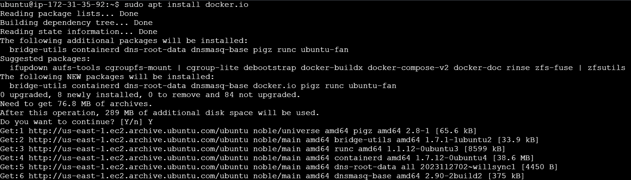

After installing docker, pull the nginx image from the docker hub registry using the following command,

$docker pull nginx

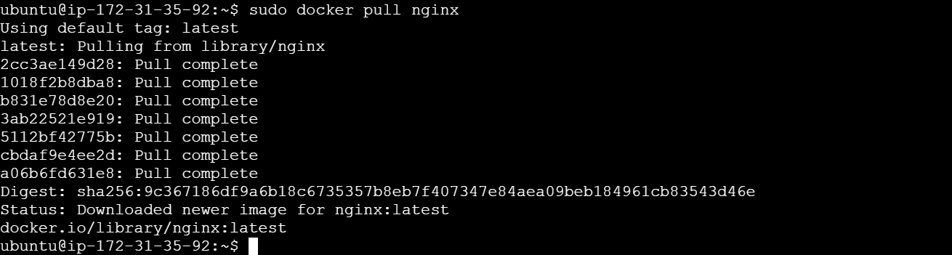

Now the webserver is configured in the Linux EC2 Instance

Part 2: Create an EBS volume of 5 GB, attach it to an EC2 machine (Windows), and take a snapshot.

Click on “Create Volume”

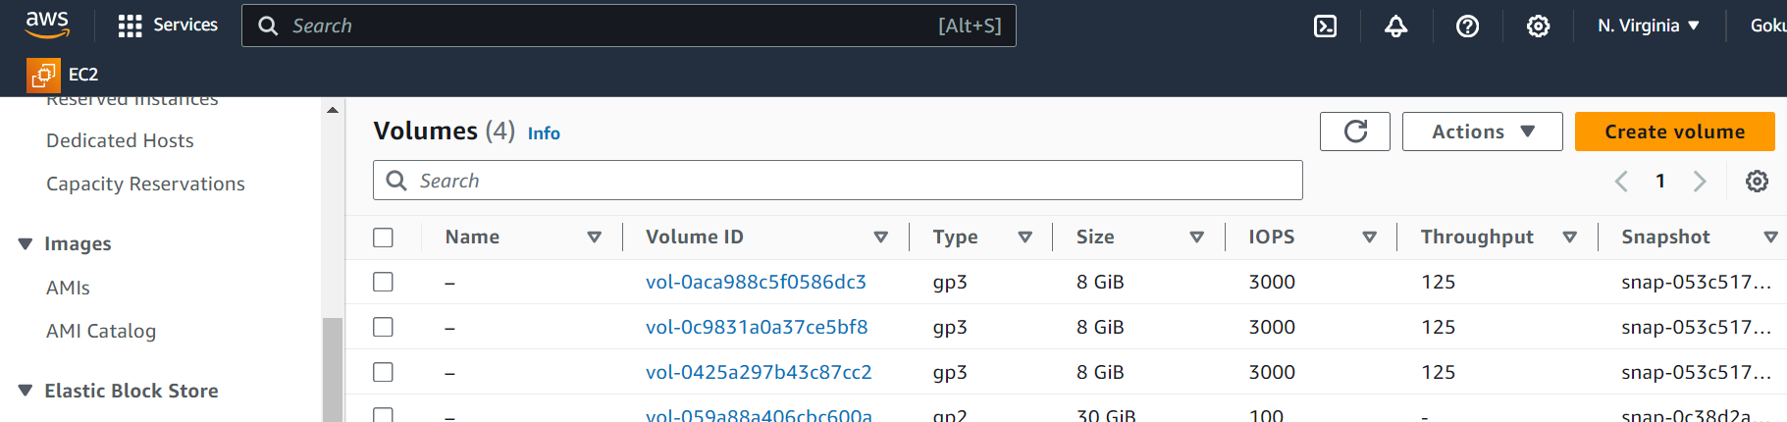

Select and fill the required configuration like Size, Availability Zone and more, and click on Create Volume

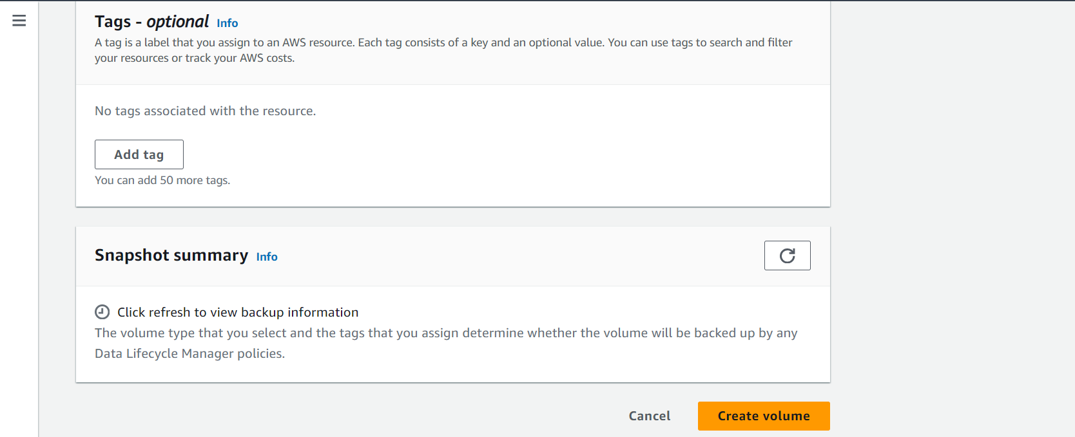

Now click on the list view page and select the created volume and select the “Attach Volume” option,

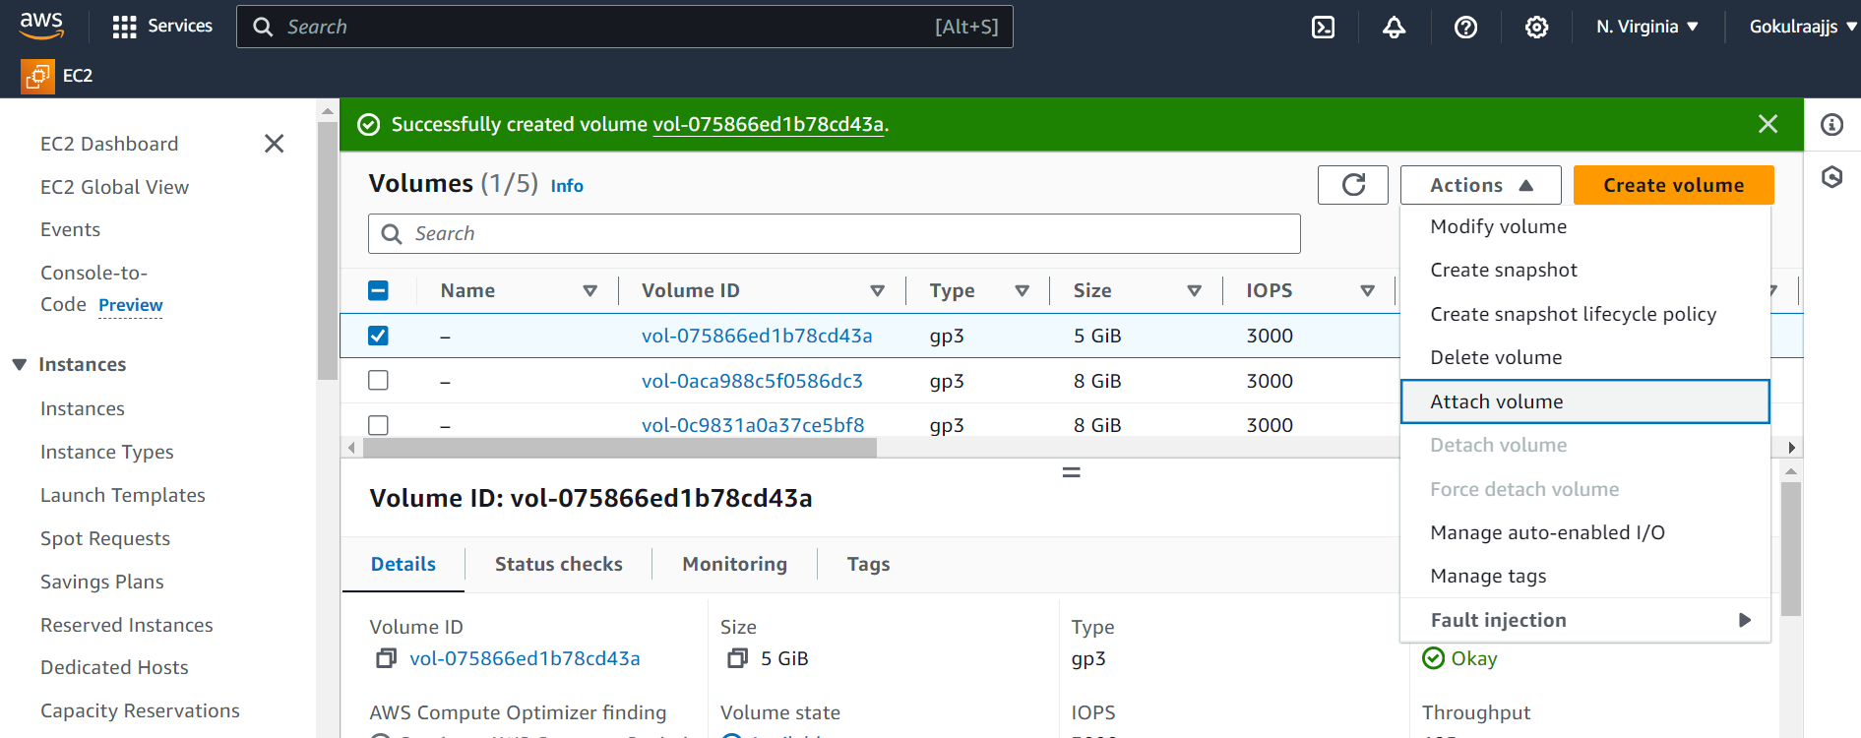

Now choose the available instances and select the name in the field and click on “Attach volume”

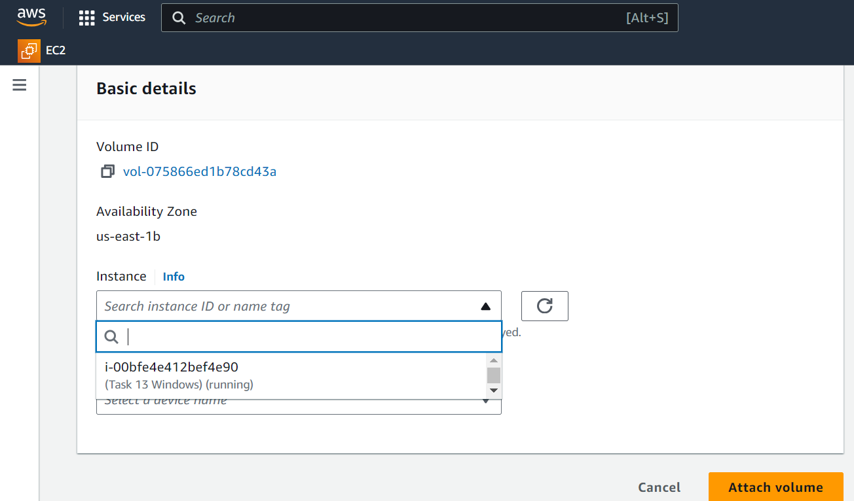

Now go to the Snapshots page and click on “Create Snapshot”

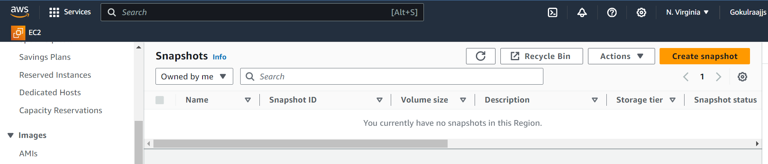

Select the available volume from the list and click “Create Snapshot”

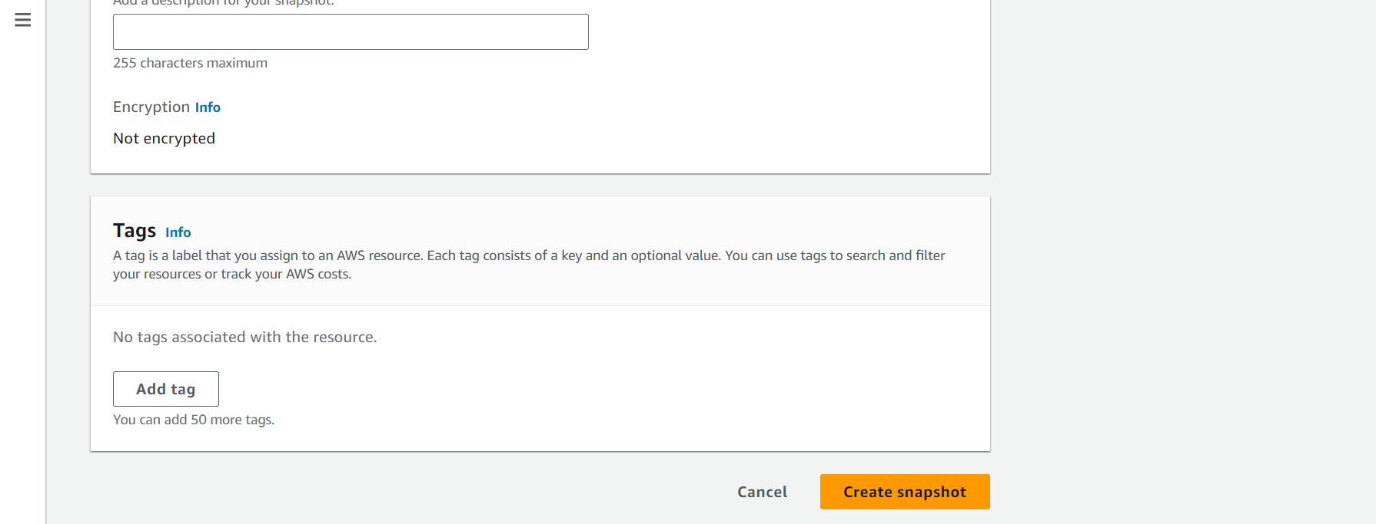

Part 3: Finally, create an EBS volume using the taken snapshot.

Click on the selected Snapshot and go to the actions and select “Create Volume from Snapshot”

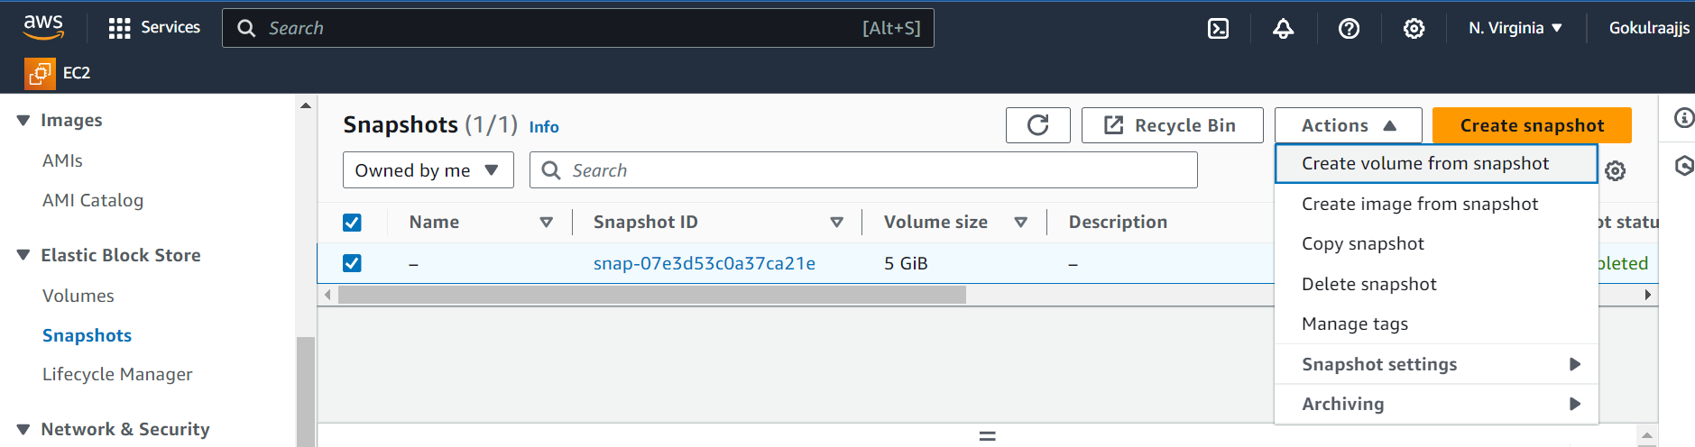

Fill all the checkbox and click “Create Volume”

